INSTRUCTIONS AND FORMS

TABLE OF CONTENTS
SUMMARY OF RFP DOCUMENTS 2
Instructions 3
1. OAA Applicant Proposal Document Checklist 3
2. Applicant Information Sheet 3
3. Applicant Authorization to Submit Certification 3
4. General Assurance Form 3
5. Proof of registration with the Ohio secretary of state as a non-profit organization or as a for-profit business 4
6. Evidence of at least one million dollars of commercial liability insurance coverage 4
7. Evidence of insurance coverage for consumer loss due to theft or property damage 4
8. A copy of the written procedure describing the step-by-step instructions a consumer may follow to file a claim 4
9. Form IRS W-9 4
10. Department of Health and Human Services Assurance of Compliance with Section 504 of the Rehabilitation Act of 1973, as amended 4
11. Certification Regarding Debarment, Suspension and Other Responsibility Matters 4
12. Organizational Chart(s) 5
13. Agency Overview Questions 5
14. Mission Statement 5
15. Strategic Plan 5
16. Current Annual Report 5
17. Most recent Audit or Financial Statement 5
18. Conditions of Participation Questions 5
20. Contract Service Page and supporting worksheets (1 set per service) 6
Definitions 13
Priority Population 13
Program Income and Cost Sharing Requirements 14
FORMS 14
OAA Applicant Proposal Document Checklist 15
Applicant Authorization To Submit Certification 16
General Assurance of Compliance with Conditions of Participation and Service Specifications 17
Department Of Health And Human Services Assurances Of Compliance With Section 504 Of THE REHABILITATION Act Of 1973, As Amended 19
Certification Regarding Debarment, Suspension and Other Responsibility Matters 20

SUMMARY OF RFP DOCUMENTS

The documents listed below outline all the requirements needed to complete the proposal application. Please review all documents before completing the application:

- Application Overview. This document provides an overview of the OAA Request for Proposal Process and provides a timeline of significant dates in the competitive proposal process.

- Instructions and Forms. This document explains how to complete the RFP and all required forms, which include assurances and descriptions of required attachments. This document also contains the application proposal checklist. All required components of a complete application are listed in the OAA Applicant Proposal Document Checklist.

- Service Specific Questions. This document includes a provider overview, conditions of participation and service specific questions. All Applicants must complete the provider overview and conditions of participation questions. Applicants should fill out only the service questions that apply to the services they are proposing to provide.

- The Ohio Department of Aging (ODA) Administrative Rules are posted on the website https://aging.ohio.gov/wps/portal/gov/aging/agencies-and-service-providers/rules-and-forms/currently-effective-rules. Providers must comply with the applicable Rules, which are part of the Ohio Administrative Code. The requirements of the Administrative Rules are incorporated by reference into and are a part of this RFP.

- Contract Workbook. This is an Excel workbook that contains: the application information sheet, contract services page, cost of service detail, source of revenue and narrative, and Nutrition Worksheets.

- 2022 Sample Contract. This contains the terms of the agreement that will be signed by successful Applicants and WRAAA, and its requirements are incorporated by reference into and are a part of this RFP.

Instructions

- OAA Applicant Proposal Document Checklist
This document outlines all documents required for a complete proposal application. This document is found in the Forms section. The completed checklist must be included as the first page of the proposal application and provides the order in which all documents must be organized.
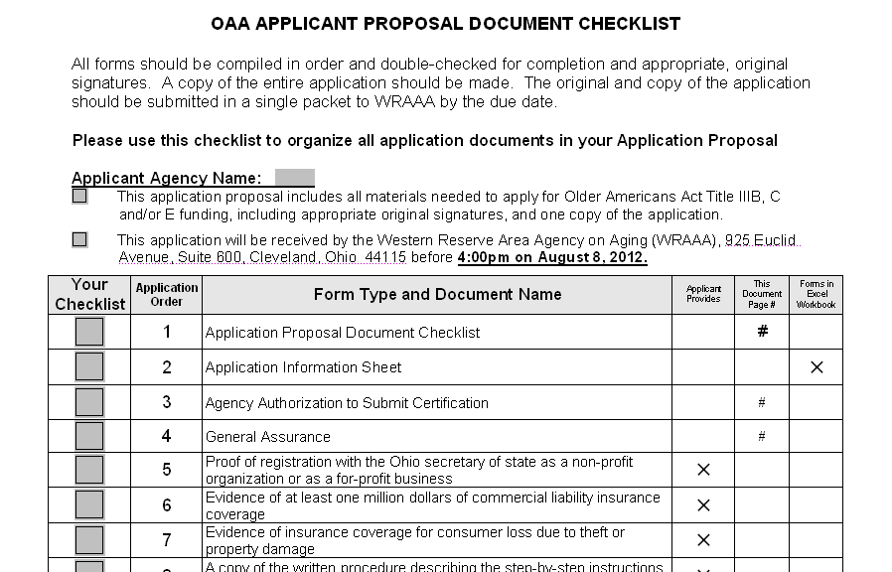

- Applicant Information Sheet
This required document provides Applicant contact information and lists the services for which the Applicant is applying. This document is found in the Excel workbook.

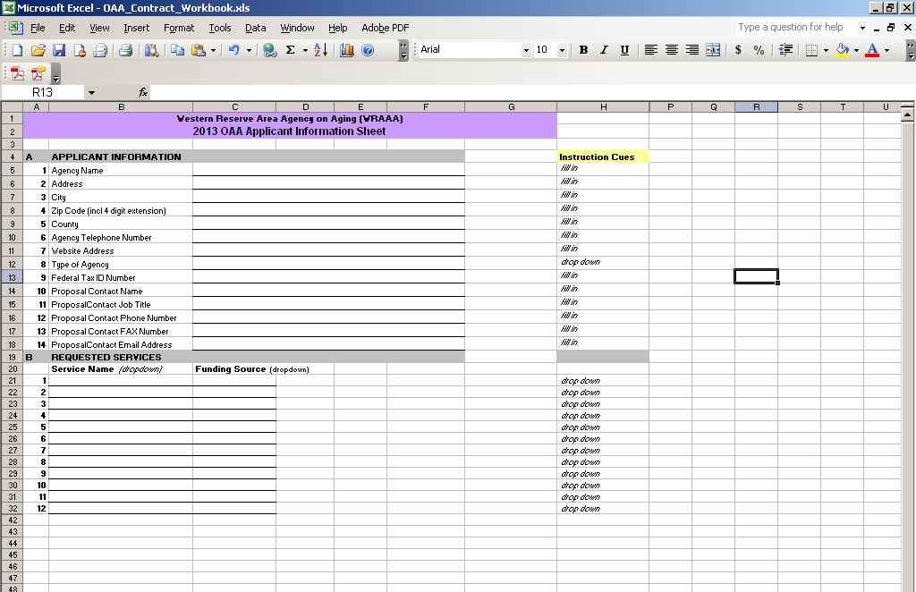

- Applicant Authorization to Submit Certification

This required document provides the Applicant with authority to submit a request for proposal. Authorized personnel must sign this document. This document is found in the Forms section. Every field should be filled in; if unapplicable, please state N/A.

- General Assurance Form

Providers applying for Older Americans Act funds must be in good standing with the Western Reserve Area Agency on Aging. The general assurance states that the Applicant is in good standing with the WRAAA and will comply with the Ohio Department of Aging and the Western Reserve Area Agency on Aging conditions of Participation, Administrative Rules, procedures, service specifications, guidelines and requirements. Authorized personnel must sign this document. This document is found in the Forms section.

- Proof of registration with the Ohio secretary of state as a non-profit organization or as a for-profit business

This is documentation that must be provided by the Applicant. The documentation is proof of registration with the Ohio Secretary of State as a non-profit organization, association, or trust, or as a co-operative, or as a for-profit business, limited liability company, limited partnership, or partnership having limited liability.

- Evidence of at least one million dollars of commercial liability insurance coverage

This is documentation that must be provided by the Applicant. The documentation must provide evidence of at least One Million Dollars of commercial liability insurance coverage aggregate and per occurrence.

- Evidence of insurance coverage for consumer loss due to theft or property damage

This is documentation that must be provided by the Applicant. The documentation must provide evidence of insurance coverage of at least $50,000.00 for consumer loss due to theft or property damage (third party fidelity or dishonesty bond). The insurance certificate shall include specific language indicating that it covers employee theft of consumer property.

- A copy of the written procedure describing the step-by-step instructions a consumer may follow to file an insurance claim

This is documentation that must be provided by the Applicant. The documentation is a copy of the written procedure describing the step-by-step instructions a consumer may follow to file an insurance claim. This is the actual document that you give to the consumer.

- Grievance Policy

This is documentation that must be provided by the Applicant. The document is the policy and procedure informing consumers about the process for filing a grievance against the Applicant.

- Form IRS W-9

Form IRS W-9 is a required document that must be completed and printed with original signatures. This document is a separate file.

- Department of Health and Human Services Assurance of Compliance with Section 504 of the Rehabilitation Act of 1973, as amended

This required document demonstrates that the Applicant agrees to comply with Section 504 of the Rehabilitation Act of 1973. Authorized personnel must complete and sign the document. This document is found in the Forms section.

- Certification Regarding Debarment, Suspension and Other Responsibility Matters

This required document certifies that the Applicant is not presently debarred, suspended, ineligible or voluntarily excluded from participation in transactions by any Federal department or agency. The Applicant also certifies that no Federal funds will be used to influence an officer or employee of a member of congress. Authorized personnel must sign the document. This document is found in the Forms section.

- Organizational Chart(s)

This is documentation that must be provided by the Applicant. The documentation must identify staff members involved in the delivery of OAA services. The chart(s) should include but is/are not limited to:
- Names,
- Titles,
- Indicate if full, part-time or volunteer and
- Lines of authority.

The chart(s) should include at least all those who are licensed or work in a supervisory or coordinating role. If it is not practical to list the names of all staff members (for example, due to the large number of aides who could potentially perform the in-home services), describe the number of aides and summarize their credentials.

- Agency Overview Questions

This required document must be completed by the Applicant applying for Older Americans Act funds regardless of the services for which they are applying. This document can be found in the Questions document.

- Mission Statement

This is documentation that must be provided by the Applicant. This documentation must state the mission and/or goals of the Applicant.

- Strategic Plan

This is documentation that must be provided by the Applicant. This documentation must outline the strategic plan of the Applicant. A strategic plan is a document used to communicate the organization’s goals, the actions needed to achieve those goals and all of the other critical elements developed during the planning exercise.

- Current Annual Report

This is documentation that must be provided by the Applicant. This documentation must include the Applicant’s most current annual report. An annual report is a document that contains comprehensive financial information about public companies, small and large corporations, non-profit organizations, partnerships, and other businesses. It includes their financial performance and activities over the prior fiscal year.

- Most recent Audit Statement

This is documentation that must be provided by the Applicant. This documentation must include the most recent audit statement of the Applicant. The term audit usually refers to a financial statement audit. A financial audit is an objective examination and evaluation of the financial statements of an organization to make sure that the financial records are a fair and accurate representation of the transactions they claim to represent.

- Conditions of Participation Questions

This required document must be completed by the Applicant applying for Older Americans Act funds regardless of the services for which they are applying. This document can be found in the Questions document.

- Service Specific Questions (Complete the questions for each service you propose to provide)

This/These required document(s) must be completed by the Applicant applying for Older Americans Act funds. Applicants should fill out only the questions related to the service(s) they are proposing to provide; please answer all questions for the service(s) you are applying for. Points will be deducted for unanswered questions and/or failure to answer questions directly. When responding to the questions that require a written answer the tables will expand to fit your comments; type as much as necessary to answer the question. When you print out the required questions, note the page numbers the questions start and end on and only print those pages.

Service specific questions include
- Adult Day Service
- Assisted Transportation
- Benefits Assistance
- Education and Training (Caregiving and/or Kinship)
- Chore Service
- Congregate Dining Project
- Evidence-Based Health Promotion
- Home-Delivered Meals Project
- Homemaking
- Information and Referral
- Legal Assistance
- Legal Counseling (Kinship)
- Nutrition Education
- Options Counseling
- Personal Care
- Restaurant Voucher Meal Service Program
- Specialized Care Coordination – Economy Security
- Specialized Information and Assistance
- Supportive Service
- Transportation
- Supportive Groups (Caregiving and/or Kinship)
- Volunteer Guardianship Service

This document can be found in the Questions document.

- Contract Service Page and supporting worksheets (1 set per service)

All the Contract Service Pages and the supporting worksheets are contained in the Excel workbook titled OAA_Contract_Workbook.xls. The following are instructions for navigating the workbook

INSTRUCTIONS: Click on the first tab to open a sheet that will provide tips for navigating through the workbook. Click on the second tab to summarize the services you are applying for and the people within your organization that WRAAA may need to contact.

STEP 1: COMPLETE THE APPLICANT INFORMATION SHEET
The APPLICANT INFORMATION SHEET (Second Tab)

Click on the Second Tab at the bottom of the Excel workbook, entitled ‘Applicant Information’, to open this sheet. All Applicants are required to submit contact information on the Applicant Information Sheet. The information you provide is used by the WRAAA Finance and Program Departments.

A hard copy of the Applicant Information Sheet must be printed and attached to the proposal packet. There are two sections:

A. Applicant Information: Provide the legal name of the Applicant. Your mailing address should include the zip code with 4-digit extension. You may use the drop-down box for the Applicant’s county. Provide the name and other details for the Proposal Contact; this should be the person who administers and is very knowledgeable about the details of your program.
B. Requested Services: Use the drop-down boxes to list each service you are applying to provide.
Save your work before moving on.
If you are a Nutrition Provider, it is helpful to fill out the meal worksheet to determine total number of meals for all of your sites before proceeding to the Contract Service Page.

STEP 2: COMPLETE The Meal Worksheet (Meal Worksheet Tab)

- Complete the informational section of the meal worksheet Contact block. Do not leave any line blank. COMMUNITY MEALS

- Enter the number of meals that you plan to provide each day for Congregate and/or Home-Delivered Meals.

- Indicate which days you will be serving meals at the site by selecting the days of the week that the site will be open. Indicate the days for Congregate and or Home-Delivered Meals

- Indicate which day(s) you will need frozen meals. Also indicate the quantity of meals you will need on those days.

- In Section C indicate which other days the site will be closed. Enter the date as MM/DD/YY. Excel will change the date to the proper format.

- This section is in green and will calculate the number of meals you are requesting in your proposal. Use these numbers on the Contract Service Page for each service for which you are requesting OAA funding.

- Print this worksheet and include it with your completed proposal documentation.

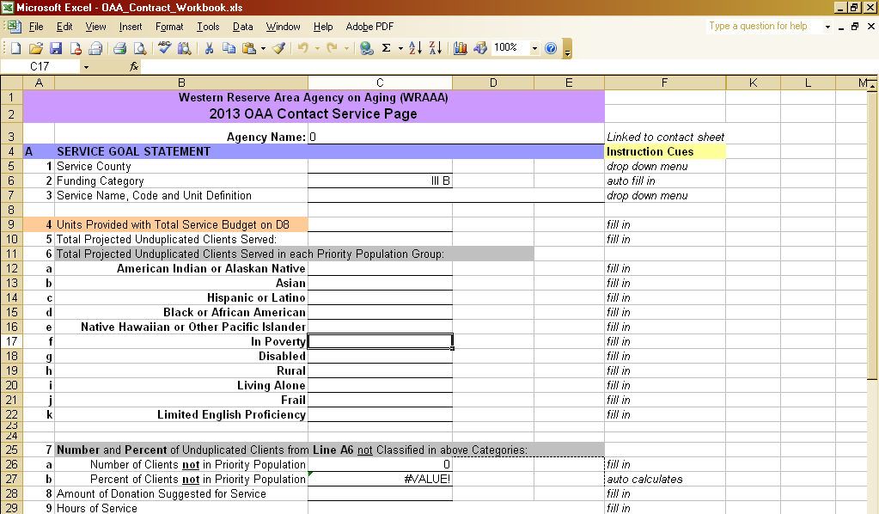
STEP 3: FILL OUT SECTION A OF THE CONTRACT SERVICE PAGE
One Set of Service Pages includes an OAA Contract Service Page (CSP), OAA Cost of Service Detail Page, and OAA Sources of Revenue and Narrative Page. A set must be completed for each proposed service. If a service is proposed to be provided to residents of more than one county, a separate set must be completed for each county. Five (5) CSP, Cost of Service Detail and Sources of Revenue and Narrative page sets are provided in the Excel Contract Workbooks. If more are needed, a second copy of OAAContractWorkbook.xls may be downloaded and saved under a different file name.

A hard copy of the final Contract Service Page, Cost of Service Detail Page, and Sources of Revenue and Narrative Page Sets must be printed and attached to the proposal packet.

It is helpful to think of the Contract Service Page as a summary or overview of the service proposal. The Cost of Service Detail Page provides supporting information in the form of a breakdown of expense categories. The Sources of Revenue and Narrative Page provides supporting information for the revenue streams, and a place to provide narrative, describe cost saving initiatives, and document any anticipated changes that may affect your projections.

Please note that some data is linked between the pages within the set. This is to ensure consistency of the data/numbers on the pages. It is helpful to enter data in the order described on the next pages. Cells are locked (i.e., data cannot be entered into them) if the value is calculated or linked to another page.

Click on the tab at the bottom of the Excel workbook, entitled ‘CSP’, to open the next worksheet. You do not have to re-enter the Applicant’s name on the Contract Service Page, Cost of Service Detail Page, or Sources of Revenue and Narrative Page. The Applicant’s name will populate at the top of each page, based on the legal name as entered on Line A1 of the OAA Applicant Information Sheet.

Section A. SERVICE GOAL STATEMENT
Refer to the Application Overview and the Rules posted at http://aging.ohio.gov/information/rules/current.aspx for Service Specifications, service definitions and unit of service measures.

- Line 1: Service County.
Indicate the County to be served. If the Applicant is serving more than one county, a contract service page set must be created for each county. ‘County’ is determined by the residential address of the client.

- Line 2: Funding Category
Choose the funding source. If you are applying for the same service from III B and III E funds, you must prepare a separate Contract Service Page set for each funding source.

- Line 3: Service Name, Code and Unit Definition Choose from a drop down menu.

- Line 4: Total Units Provided with Total Service Budget on Line D8
Care should be taken to reasonably project the number of service units, since WRAAA requires delivery of 100% of the contracted units in order to be eligible for receipt of 100% of the OAA award.

Units of Service may be determined by using any of the two methods described below:

- Calculations based on actual annual operating experience and/or projected service expansion.
ii. Calculations based on the average number of incremental units that are proposed to be provided with OAA funding per day, multiplied by the number of service days in the contract year. For a five day a week service, use 250 contract days (5 days / week x 52 weeks / year minus 10 holidays = 250 contract days). The formula is:

Average incremental OAA Units/Day X Number of Service Days/Year = Total OAA Units/Year*

*NOTE: Other factors may need to be considered for each service and Applicant (e.g., client turnover).

The number should include only the incremental units proposed to be supported with OAA funds. Do not include units supported primarily through other means (for example, PASSPORT or private pay).

- Line 5: Total Projected Unduplicated Clients to be Served
OAA Title IIIE National Family Caregiver Support services benefit both the caregiver and the care recipient. When filling out Line A6 – A8 for these services consider the caregiver as the client. For all other OAA services, however, the Client is the Consumer (the Care Recipient).

1. Base estimates of projected unduplicated OAA clients to be served on actual operating experience and/or projected outreach and service expansion.

2. Determine the average number of units each OAA client is projected to receive per year and divide into the total units, which equals unduplicated client count. The formula is:

Total OAA Units / Average Units per OAA Client = Projected Unduplicated Clients

- Line 6a-k: Total Projected Unduplicated Clients to be Served in each Priority Population
Project the number of clients to be served according to the stated Priority Population characteristics. Refer to the definitions of the Priority Populations. Do not report as a percentage.

- Line 7a and b: Number and Percent of Unduplicated Clients from Line 6 not Classified in any of the above Priority Population categories.
Input the projected number of unduplicated clients who do not qualify for Priority Population status. The percent of the total unduplicated clients who do not qualify for Priority Population status will be calculated. Outreach should be focused on Priority Populations; optimally, the calculated percentage will be lower than the overall demographics for the community indicate.

- Line 8: Amount of Donation Suggested for Service
This suggested donation amount (per unit of service) should be posted or published to encourage donations, which are reported in aggregate as Program Income on Line B5. The suggested donation amount should be provided in your service description literature.

- Line 9: Hours of Service
Indicate the actual hours that the service is offered.

- Line 10: Location of Service Delivery
Indicate the location of where the service will be delivered.
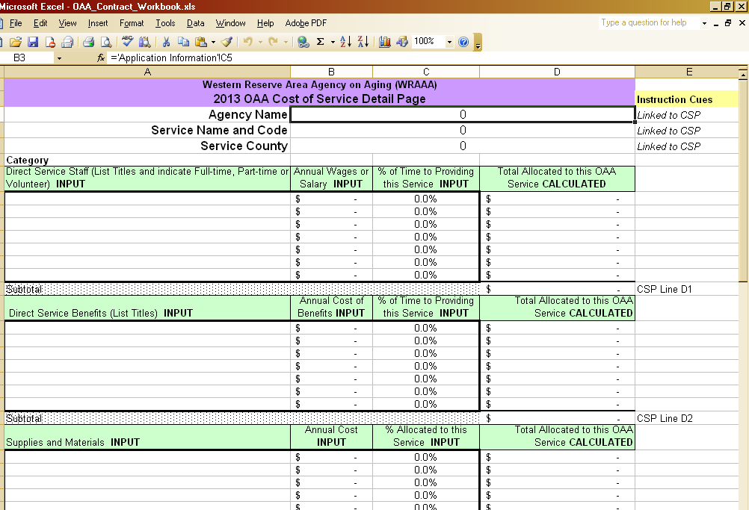
Save your work before moving on.

STEP 3: COMPLETE FORM THE COST OF SERVICE DETAIL PAGE
Click on the next tab entitled ‘COST’ to open the Cost of Service Detail worksheet. Here, the total service budget for the number of units proposed to be served with OAA funding (on Line A4 of the Contract Service Page) can be built up from its cost elements. The cells where data can be entered are outlined in bold.

The Applicant’s name, Service Name and Code, and Service County will populate the top of the Cost of Service Detail worksheet from data entered in the previous CSP.

The Cost of Service Detail documents the expenses associated with providing the service. This includes staff salary, wages and benefits, program supplies and materials, and all other expenses incurred while providing the OAA service. Similar expenses can be grouped together. However, a reasonable portrayal of the costs associated with the provision of the service should be shown. The categories are discussed in more detail below.

Cost allocation formulas must be developed, documented and utilized when cost items are chargeable to more than one funding source or program budget. The percentage applicable to OAA units can be entered into the Cost of Service Detail page. (The basis for the percentage does not need to be submitted with this application, but should be retained and available for later financial audit review.)

Costs of non-OAA funded programs or services should not be reflected in the Unit Cost Detail.

Category

Direct Service Staff: List titles and indicate if full-time, part-time or volunteer. Direct Service Staff includes only those who work directly with the clients. Enter the annual wages or salary of the direct staff. Estimate the % of their time allocated to provide the proposed units of OAA service. The spreadsheet will calculate the total dollars of their salary allocated to providing this OAA service.

Direct Service Benefits: List the titles of those Direct Service Staff who receive benefits, and the annual cost of those benefits. Indicate the % of their time allocated to provide the proposed units of OAA service.

Supplies and Materials: List similar types of supplies and materials that are consumed in your program or while providing your service. Estimate the annual cost for those supplies, and indicate the percentage that would be consumed in support of the proposed OAA units.

Service Travel and Transportation: List the annual cost of travel related to your service. This should not include Transportation of your clients to your site.

Other Direct Service Costs: List other broad groups of other costs that you incur.

Indirect Administrative Staff: List the titles, and indicate if full-time, part-time or volunteer, for staff members who support the provision of service indirectly. Enter the annual cost of salary and wages. Estimate the % of their time allocated to support the proposed units of OAA service.

Indirect Administrative Staff Benefits: List the titles of those indirect service staff who receive benefits. Enter the annual cost of those benefits. Estimate the % of their time allocated to support the proposed units of OAA service.
Other Indirect Costs: List other broad groups of other costs that you incur, for example, the cost of liability insurance.

The Total Cost Allocated to this OAA Service will be calculated. The data will also populate the Unit Cost Detail in Section D of the Contract Service Page.
Save your work, and click on the Third Tab entitled ‘CSP’ and return to the Contract Service Page. Review the data in Section D, Unit Cost Detail. Ensure that the calculated Total Service Budget,
Cost / Unit, and Percentages are accurate. If needed, return to the Cost of Service Detail Page to make corrections.

STEP 4: FILL OUT SECTION B OF THE CONTRACT SERVICE PAGE
Now that the Total Service Budget has been built up from cost components, the Proposed Revenue Sources (Section B of the CSP) can be developed.
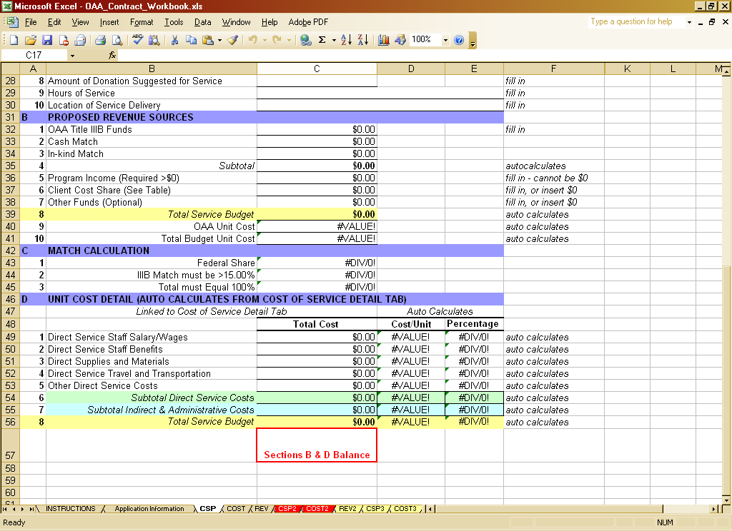

Section B. Proposed Revenue Sources
- Line 1: OAA Funds
Enter the amount of funds that you are requesting from WRAAA for the provision of the units of service described in Section A.

- Line 2 and 3:
Enter your matching funds, which are required for OAA funding. They may be cash or in-kind.

- Line 5: Program Income (Required)
This is the estimated aggregate amount of donations received through the term of the contract. All services require the ability and willingness to collect Program Income. A value of $1.00 or larger must be entered on this line.

- Line 6: Client Cost Share (Optional for some services)
Under OAA funding, Client Cost Share is required for many services, but prohibited for some. Refer to the Program Income and Cost Sharing Requirements in the Definitions portion of this document for the requirements. If a cost share procedure is utilized, the aggregate amount of funds received from the sliding fee scale invoices should be projected and entered. If cost sharing is practiced, the procedure must comply with Rule 173-3-07.

- Line 7: Other Funds (Optional)
If funds from other sources are utilized to provide the service, they should be reported here.

STEP 5: ENSURE THAT THE TOTAL SERVICE BUDGET BALANCES
The Total Service Budget is calculated by adding the Proposed Revenue Sources together on Line B8. It should be compared to the Total Service Budget calculated by adding the Cost of Service data on Line D8. Adjustments must be made so that the Total Service Budget is the same whether calculated from the Proposed Revenue Sources or Cost of Service data. The spreadsheet will indicate if Lines B8 and D8 agree, and will provide a warning message when Lines B8 and D8 are not the same.

Do not proceed until Lines B8 and D8 of the Contract Service Page agree.

Once Lines B8 and D8 agree, save your work.

STEP 6: ENSURE THAT MATCHING FUNDS ARE SUFFICIENT

The match is calculated in Section C. Ensure that your match exceeds 40.00% for catered congregate and home-delivered meals, and 15.00% for all other services.
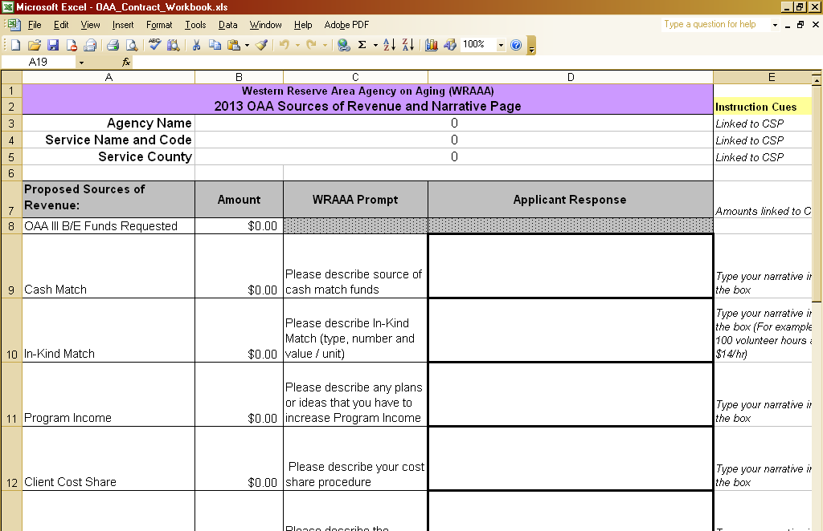
STEP 7: COMPLETE FORM THE SOURCES OF REVENUE AND NARRATIVE PAGE

Click on the tab at the bottom of the workbook, entitled ‘REV’, to open the Revenue Sources and Narrative Page. The cells will populate from data on the CSP page. Provide concise narrative in the cells outlined in bold.

STEP 8: COMPLETE A SET OF FORMS FOR EACH ADDITIONAL SERVICE

Click on the tab at the bottom of the workbook to open a new Contract Service Page entitled ‘CSP2’. Repeat STEPS 2 – 6 for each additional service that you propose to provide with OAA Funding, using the associated tabs ‘COST2’ and ‘REV2’.

Total funding is allocated via formula between the counties. Therefore, if you propose to serve the residents of more than one county, repeat STEPS 2 – 6 for the funding requested for each additional county.

For example, if an Applicant proposes to provide Adult Day Service and Homemaking in Cuyahoga and Lorain counties, four (4) sets of forms would need to be provided: Adult Day Service for Cuyahoga, Adult Day Service for Lorain, Homemaking for Cuyahoga, and Homemaking for Lorain.

If you need more sets of the Forms, download another copy of the worksheet and save it with a different name.

Definitions

Priority Population
For OAA Contracts

WRAAA requires that providers target services to priority populations within a defined geographic area of service and record demographic data in order to track progress toward goals.
- Minority Status:
  - American Indian or Alaskan Native
  - Asian
  - Hispanic or Latino
  - Black or African American
  - Native Hawaiian or Other Pacific Islander

- In Poverty – Those whose income is at 100% of, or below, the official poverty guideline.

- Disabled – A person with mental or physical impairment, or a combination of mental or physical impairments, that result in substantial functional limitations in 1 or more of the following areas of major life activity: (A) self-care, (B) receptive and expressive language, (C) learning, (D) mobility, (E) self-direction, (F) capacity for independent living, (G) economic self-sufficiency, (H) cognitive functioning, and (I) emotional adjustment.

- Rural – A person living in any area that is not urban. Urban areas comprise (1) urbanized areas (a central place and its adjacent densely settled territories with a combined minimum population of 50,000) and (2) an incorporated place or a census designated place with 20,000 or more inhabitants.

- Living Alone – A person living in a one-person household, where the householder lives by his or herself in an owned or rented place of residence in a non-institutional setting.

- Frail – A person who is unable to perform at least two activities of daily living (bathing, dressing, toilet use, eating, walking, and transfer - for example, from bed to chair) without substantial human assistance, including verbal reminding, physical cueing, or supervision. In this context, ‘Frail’ has the same meaning as ‘At Risk of Institutionalization’.

- Limited English Proficiency – A person whose primary language is not English. Note: There is a disconnect between this terminology and SAMS, which has been identified as a needed enhancement, however it cannot be changed at this time. In SAMS, you have to enter the data in answer to the question “Understands English”. Although the person may understand English, if it is not their primary language you should enter ‘No’, in order to capture the information we are targeting, which is “Limited English Proficiency”.

Program Income and Cost Sharing Requirements

Service | Program Income | Cost Sharing
Adult Day Service | Required | Required
Congregate Meals | Required | Prohibited
Home Delivered Meals | Required | Prohibited
Restaurant Vouchers | Required | Prohibited
Nutrition Education | Not Required | Prohibited
Homemaker | Required | Required
Personal Care | Required | Required
Transportation | Required | Prohibited
Coordinated Transportation | Required | Prohibited
Escort Service | Required | Prohibited
Supportive Services | * | Prohibited
Caregiver Education & Training  (including Kinship) | Required | Prohibited
Caregiver Support Group  (including Kinship | Required | Prohibited
Volunteer Guardianship Services | * | Prohibited
Legal Assistance  (including Kinship) | * | Prohibited
Chore | Required | Required
Home Maintenance, Repair & Modification | Required | Required

- Donations may be obtained through general solicitations from a consumer who receives the service rather than directly asking the individuals utilizing these services.

FORMS

The forms on the following pages are referenced on the OAA Applicant Proposal Document Checklist and should be completed by all agencies that are submitting a proposal.

OAA Applicant Proposal Document Checklist
All forms should be compiled in order and double-checked for completion and appropriate, original signatures. A copy of the entire application should be made. The original and copy of the application should be submitted in a single packet to WRAAA by the due date.

Please use this checklist to organize all application documents in your Application Proposal

Type Applicant’s Name:

This application proposal includes all materials needed to apply for Older Americans Act Title IIIB, C and/or E funding, including appropriate original signatures, and one copy of the application.
Your Checklist | Application Order # | Form Type and Document Name | Applicant  Provides | Document | Forms in Excel Workbook
 | 01 | Application Proposal Document Checklist |  | Instructions & Forms
 | 02 | Application Information Sheet |  |  | X
 | 03 | Applicant Authorization to Submit Certification |  | Instructions & Forms
 | 04 | General Assurance |  | Instructions & Forms
 | 05 | Proof of registration with the Ohio secretary of state as a non-profit organization or as a for-profit business | X
 | 06 | Evidence of at least one million dollars of commercial liability insurance coverage | X
 | 07 | Evidence of insurance coverage for consumer loss due to theft or property damage | X
 | 08 | A copy of the written procedure describing the step-by-step instructions a consumer may follow to file a claim | X
 | 09 | Grievance Policy | X
 | 10 | Form IRS W-9 |  | Form W9
 | 11 | Department of Health and Human Services Assurance of Compliance with Section 504 of the Rehabilitation Act of 1973, as amended |  | Instructions & Forms
 | 12 | Certification Regarding Debarment, Suspension and Other Responsibility Matters |  | Instructions & Forms
 | 13 | Organizational Chart | X
 | 14 | Provider Overview Questions |  | Service Specific Questions
 | 15 | Mission Statement | X
 | 16 | Strategic Plan | X
 | 17 | Current Annual Report | X
 | 18 | Most Recent Audit Statement | X
 | 19 | Conditions of Participation Questions |  | Service Specific Questions
 | 20 | Service Application Questions (Complete the questionnaire for each service you propose to provide) |  | Service Specific Questions
 | 21 | Contract Service Page and supporting worksheets (1 set per service) |  |  | X
 | 22 | Meal Worksheet(s) 1 per nutrition site proposed if proposing nutrition services |  |  | X

Applicant Authorization To Submit Certification

On behalf of APPLICANT: , a prospective “Provider” within the meaning of O.A.C. 173-3-01(B)(17), ( I / We) the undersigned, certify(ies) that all information (including funding levels) is true to the best of my / our knowledge.
This application was approved and authorized for submission to the WRAAA, in accordance with O.A.C. 173-3-01(B)(17), by , (Name of “Consumer-directed individual provider”, “Applicant Provider” or “Self-Employed Provider”) during a meeting (if applicable) held (Date of Meeting).
Should I / this Applicant receive the grant(s) applied for, I / We will fulfill the intent of the application. I / We further understand that additional documentation will be required after grants are awarded and agree to comply with AAA requirements regarding it.
Primary business telephone number or toll-free telephone number of Applicant:
( ) -

Facsimile number of Applicant:
( ) -

IF AN ENTITY:
Legal Name of Applicant (Please type legal name of Applicant on line below):

President, Governing Board (if applicable) (Please type name of President on line below):

Signature of President (if applicable):

Date:

Director of Applicant (if applicable) (Please type name of Director on line below):

Signature of Director (if applicable):

Date:

IF AN INDIVIDUAL:
Please type name and role of individual on line below:

Signature of Individual:

Date:

General Assurance of Compliance with Conditions of Participation and Service Specifications
(Page 1 of 2)

The Applicant hereby assures and certifies that it is in good standing with the Western Reserve Area Agency on Aging and will comply with the ODA and WRAAA Conditions of Participation, Administrative Rules, procedures, service specifications, guidelines and requirements, as they relate to the application, acceptance and use of Older Americans Act (OAA) funds for the Applicant's proposed aging services program. The Applicant also assures and certifies that:

- It recognizes that although quality assurance practices and procedures are mandated and monitored by the ODA and WRAAA, it is the Applicant that must retain ultimate responsibility for the quality assurance function; it further recognizes that the overall responsibility for ensuring quality rests within the provider's organization.

- It shall comply with the ODA/WRAAA Conditions of Participation in the Administrative Rules, which focus on Applicant’s operations and consumer care, including: Rule 173-3-06 regarding mandatory clauses, Rule 173-9 regarding criminal records check, 173-3-07 regarding consumer cost share, and WRAAA Policies and Procedures.

- It shall comply with ODA Administrative Rules for Nutrition services: 173-4-01 for Introduction and definitions; 173-4-02 for Eligibility criteria; 173-4-03 for Enrollment process; 173-4-05.1 for Congregate Dining Project; 173-4-05.2 for Home-delivered Meals Project; 173-4-05.3 for Restaurant and grocery meal service; 173-4-05 for Meal service; 173-4-09 for Nutrition health screening service; and 173-4-08 for Nutrition education service.

- It shall comply with ODA Administrative Rules for the following services: 173-3-06.1 for Adult day care services; 173-3-06.2 for Chore; 173-3-06.4 for Homemaker services, and 173-3-06.5 for personal care services, and WRAAA specifications for other services. The Applicant acknowledges responsibility as to compliance and awareness that failure on its part to comply may constitute sufficient basis for (1) a finding by WRAAA of lack of administrative capability, and (2) imposition by WRAAA of appropriate sanctions.

TRANSPORTATION

- Funds awarded as a result of this proposed request shall be expended for the purposes set forth herein and in accordance with all applicable laws, regulations, policies and procedures of the Western Reserve Area Agency on Aging and the Ohio Department of Aging.

- The Applicant's employment practices (including recruitment and employment), provision of services, and purchasing or subcontracting of goods and services shall be non-discriminatory in accord with all applicable laws and regulations. The Applicant further assures that no portion of its program(s) for which WRAAA funding is sought will in any way discriminate against, deny benefits to, deny employment to, or exclude from participation any persons on the grounds of race, color, national origin, religion, age, sex, handicap, political affiliation or belief, or any other legally protected classification. Effort shall be made by Applicant to make programs and facilities accessible to eligible qualified handicapped and disabled persons.

- The Applicant assures that it complies with all federal wage and hour laws, and all workers’ compensation laws.

- Any proposed changes in the proposal as approved shall be submitted in writing by the Applicant and upon written notification of approval by WRAAA shall be deemed incorporated into and become part of this Agreement.

General Assurance of Compliance with Conditions of Participation and Service Specifications
(Page 2 of 2)

- The Applicant agrees to comply with all provisions of the contract and requirement of Federal and State law.

- The Applicant understands that funds awarded may be increased or decreased at any time due to changes in Federal or State funding

- Funds awarded by the Western Reserve Area Agency on Aging [WRAAA] may be terminated at any time for violation of any terms, conditions and/or requirements of this RFP or an Agreement between Applicant and WRAAA.

- The Applicant also recognizes and agrees that OAA funds will be extended in reliance on the representation and agreements made in this Assurance and that the ODA and WRAAA will have the right to enforce this Assurance through lawful means. This Assurance is binding on the Applicant, its successors, transferees, and assignees, and the person or persons whose signatures appear below as authorized to sign this Assurance on behalf of the Applicant.

- The Assurance obligates the Applicant for the period of its service contract to proceed in good faith and in cooperative effort to bring those services subject to quality assurance which are contracted for into compliance with all applicable quality assurance standards and requirements.

- The Applicant affirms, understands and will abide by the requirements of Executive Order 2019-12D banning the expenditure of public funds on offshore services issued by Ohio Governor Mike DeWine. The Executive Order is available at the following website: (http://www.governor.ohio.gov/wps/portal/gov/governor/Media/Executive-Orders/2019-12d.pdf).

IF AN ENTITY:

LEGAL NAME OF APPLICANT (TYPE)

SIGNATORY NAME (TYPE)

TITLE OF SIGNATORY (TYPE)

SIGNATURE OF AUTHORIZED OFFICIAL DATE

IF AN INDIVIDUAL:

NAME AND ROLE OF INDIVIDUAL (TYPE)

SIGNATURE OF INDIVIDUAL DATE

Department Of Health And Human Services Assurances Of Compliance With Section 504 Of THE REHABILITATION Act Of 1973, As Amended

The undersigned (hereinafter called the "recipient") HEREBY AGREES THAT it will comply with Section 504 of the Rehabilitation Act of 1973, as amended (29 U.S.C. 794), all requirements imposed by the applicable HHS regulation (45 C.F.R. Part 84), and all guidelines and interpretations issued pursuant thereto.

Pursuant to 84.5(a) of the regulation {45 C.F.R. 84.5 (a)}, the recipient gives this Assurance in consideration of and for the purpose of obtaining any and all federal grants, loans, contracts (except procurement contracts and contracts of insurance or guaranty), property, discounts, or other federal financial assistance extended by the Department of Health and Human Services after the date of this Assurance, including payments or other assistance made after such date on application for federal financial assistance that were approved before such date. The recipient recognizes and agrees that such federal financial assistance will be extended in reliance on the representation and agreements made in this Assurance and that the United States will have the right to enforce this Assurance through lawful means. This Assurance is binding on the recipient, its successors, transferees, and assignees, and the person or persons whose signatures appear below are authorized to sign this Assurance on behalf of the recipient.

This Assurance obligates the recipient for the period during which federal financial assistance is extended to it by the Department of Health and Human Services or, where the assistance is in the form of real or personal property, for the period provided for in 84.5(b) of the regulation {45 C.F.R. 84.5(b)}.
The recipient: {Check (a) or (b)}
a. employs fewer than fifteen persons;
b. employs fifteen or more persons and, pursuant to §84.7(a) of the regulation [45 C.F.R 84.7(a)], has designated the following person(s) to coordinate its efforts to comply with the Health and Human Services regulations:

Name of Designee (Type or Print)

Name of Recipient (Type or Print)

Street Address or P.O. Box

City, State Zip

(IRS) Employer Identification Number

Area Code - Telephone Number

I certify that the above information is complete and correct to the best of my knowledge.

______________________________ _______________________________
Date Signature and Title of Authorized Official

Certification Regarding Debarment, Suspension and Other Responsibility Matters

By signing this proposal, Applicant certifies to the best of its knowledge and belief that it and its principals are not presently debarred, suspended, proposed for debarment, declared ineligible, or voluntarily excluded from participation in this transaction by any Federal department or agency. If Applicant, as a subcontractor, is unable to certify to any of the above, it shall attach an explanation to this agreement. Applicant further agrees that it will include this clause entitled "Certification Regarding Debarment, Suspension, Ineligibility, and Voluntary Exclusion - Lower Tier Covered Transactions" without modification in all lower tier covered transactions and in all solicitations for lower tier covered transactions.

Certification Regarding Lobbying

By signing this proposal, Applicant certifies, to best of its knowledge and belief, that: (1) No Federal appropriated funds have been paid or will be paid, by or on behalf of the subcontract, to any person for influencing or attempting to influence an officer or employee of any agency, a Member of Congress, an officer or employee of Congress, or an employee of a Member of Congress in connection with the awarding of any Federal contract, the making of any Federal grant, the making of any Federal loan, the entering into of any cooperative agreement, and the extension, continuation, renewal, amendment, or modification of any Federal contract, grant, loan, or cooperative agreement. (2) If any funds other than Federal appropriated funds have been paid or will be paid to any person for influencing or attempting to influence an officer or employee of any agency, a Member of Congress, an officer or employee of Congress, or an employee of a Member of Congress in connection with this Federal contract, grant, loan or cooperative agreement, the subcontract shall complete and submit Standard Form-LLL, "Disclosure Form to Report Lobbying," in accordance with its instructions. (3) the subcontractor shall require that the language of this certification be included in the award documents for all subawards at all tiers (including subcontracts, subgrants, and contracts under grants, loans, and cooperative agreements) and that all subrecipients shall certify and disclose accordingly.

This certification is a material representation of fact upon which reliance was placed when this transaction was made or entered into. Submission of this certification is a prerequisite for making or entering into this transaction imposed by section 1352, title 31, U.S. Code. Any person who fails to file the required certification shall be subject to a civil penalty of not less than $10,000 and not more than $100,000 for each such failure.

Note: If Disclosure Forms are required, please contact: Mr. William Sexton, Deputy Director, Grants and Contracts Management Division, Room 341F, HHH Building, 200 Independence Avenue, SW, Washington, D.C. 20201-0001.

____________ ____________________________________
Date Signature and Title of Authorized Official

CL2:523983_v1

